App in a Day

Hands-on Lab Step-by-Step

May 2020

Contents

Importing Module 2 Completed 1

Task 1: Create a new environment 1

Task 2: Import the solution 2

# Importing Module 2 Completed

Follow the steps below, if you did not complete Module 1 or Module 2 and would like to skip to Module 3

## Task 1: Create a new environment

1. Open a new browser tab, navigate to [Power Apps admin portal](https://admin.powerplatform.microsoft.com/) select **Environments** and click **New Environment**.

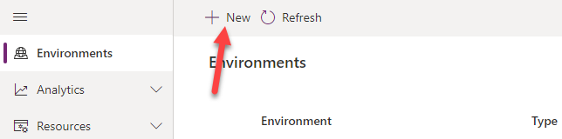

1. Provide an **Environment Name**, select **Trial** for **Type**, select **Region**, select **Yes**, for **Create** a database, and click **Next**.

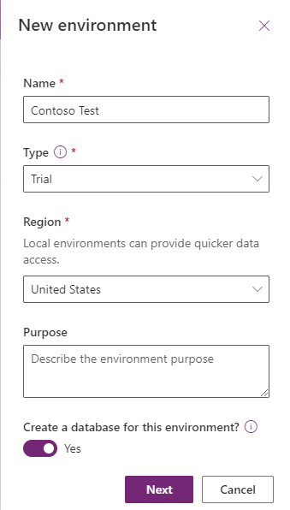

1. Select **Language,** select **Currency**, select **Yes** for **Deploy sample apps** **and data** and then click **Save**.

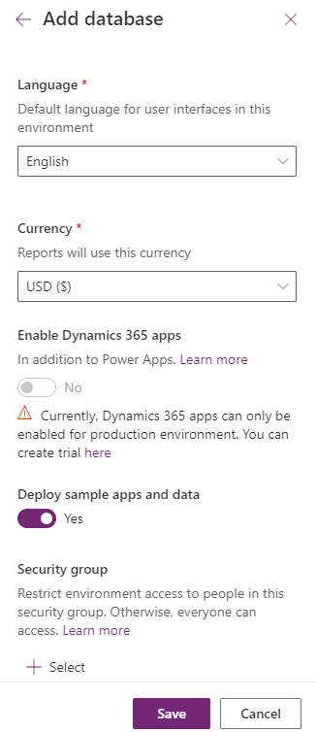

1. Wait for the environment to be created.

## Task 2: Import the solution

In this task, you will import the completed module 2 solution.

1. Navigate to [Power Apps maker portal](https://make.powerapps.com/)
2. Make sure you are in the **Contoso Test** Environment you created.
3. Select **Solutions** and click **Import**.

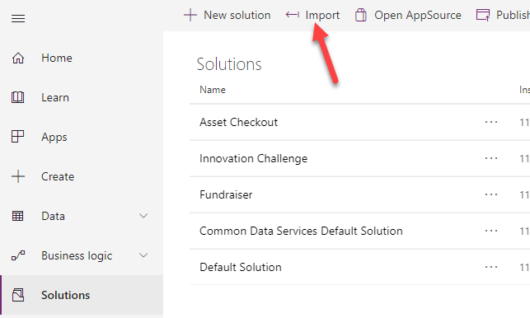

1. Click **Browse**.

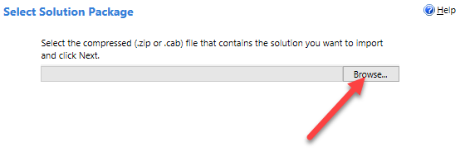

1. Select Mod 2 Completed Solution and click Open.

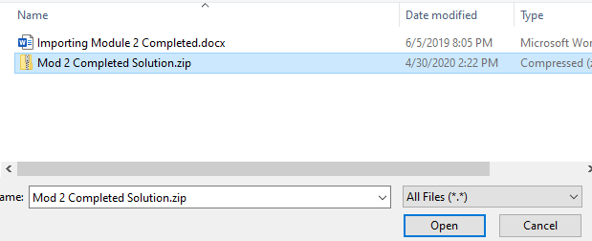

1. Click **Next**.

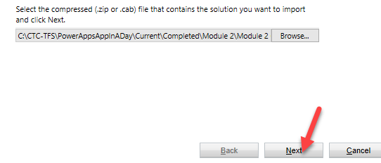

1. Click **Next**.
2. Click **Import**.
3. Wait for the import to complete and click Close.

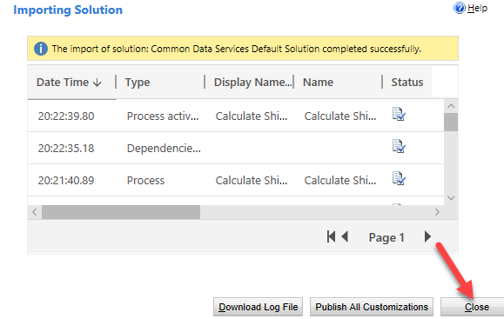

1. Select **Apps**, click on the … button of the application you imported and click **Play**.

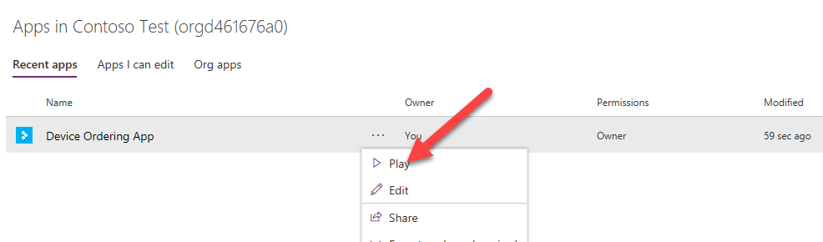

1. Click **Allow**.

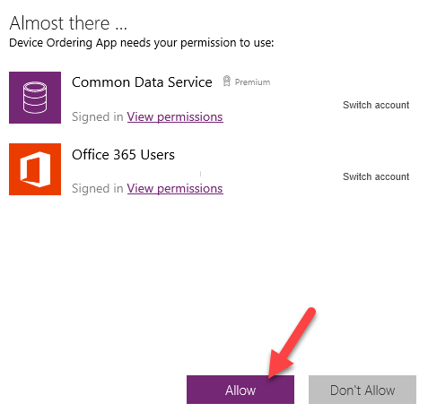

1. Select a few devices and click **Compare**.

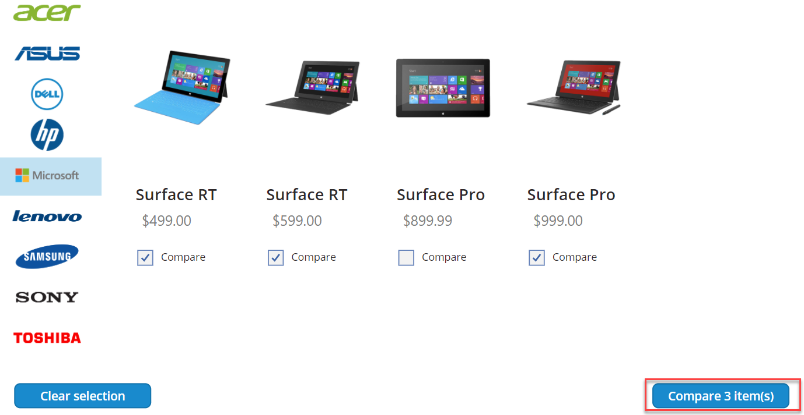

1. Select one of the devices and click **Submit**.

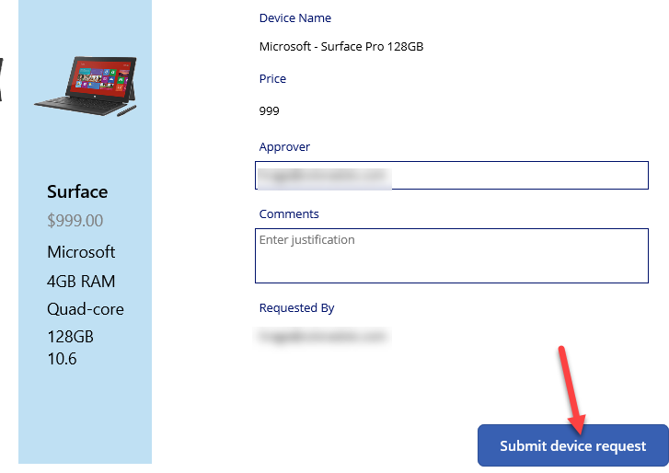

1. Click **OK**.

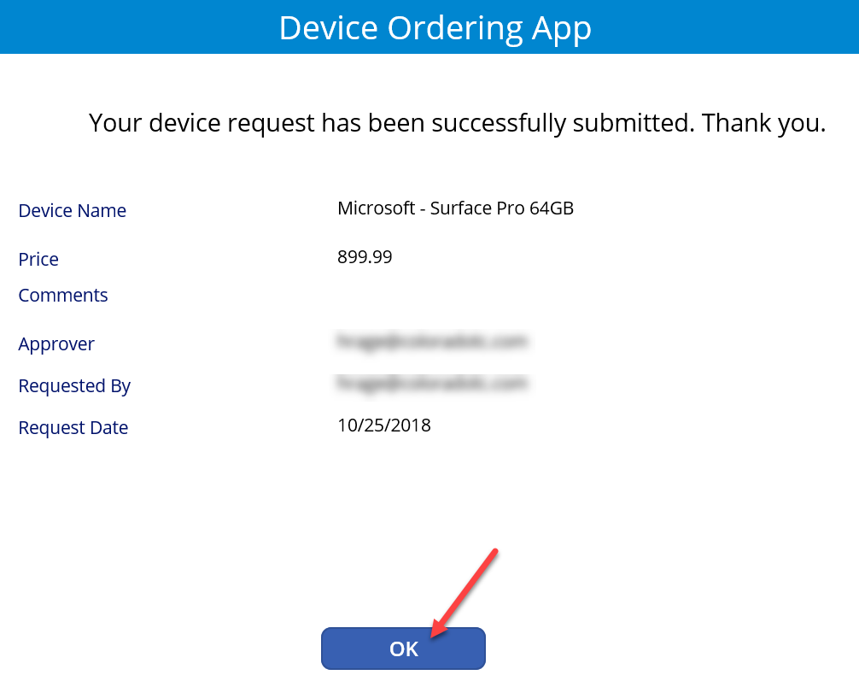

1. Close the application.
2. Expand **Data**, select **Entities**, search for **Device Order** and click on it.

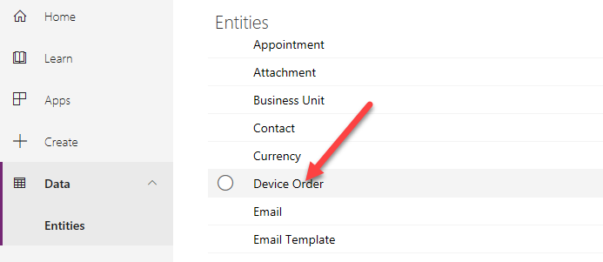

1. Select the Data tab and make sure you have at least one record in the table.

